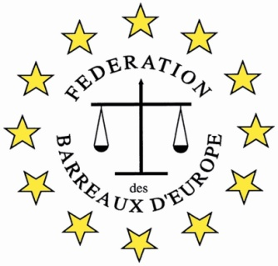

FBE III International Young Lawyers’ and Law Students’ Human Rights Oratory Competition, Bilbao 2022

WHERE?
In Bilbao, Spain

WHEN?
September 2-3 2022

WHO?
Lawyers and Law Students under 35 years of age

WHY?
The Competition is a great opportunity to:
- practice and improve oratory skills
- learn to present a case to an international audience of lawyers
- develop legal English and general oral English skills
- meet with lawyers from jurisdiction across Europe
- enjoy Bilbao

THE ORGANIZATION
The Competition is organized by the European Bars Federation (FBE)/ its Human Right Commission and will be hosted by the Bilbao Bar.

WHAT YOU WILL DO
Prepare a 10 minutes speech on: “War Crimes” to be presented to an International Jury in Bilbao with other participants from different countries.
If selected amongst the four best contestants, defend a position against an opponent on another topic the following day.

HOW TO APPLY
Applications should be completed on the accompanying form and approved by the sending Bar Association. Please contact your Bar and send your application to the relevant person. The form must then be sent to fbehumanrightscompetition@gmail.com by 12.00 midday on 16 August 2022

