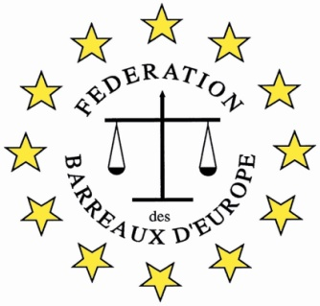

The FBE III International Young Lawyers’ and Law Students’
Human Rights Oratory Competition, Bilbao
“War Crimes”

Application Form
(.doc format)

The Bar
Participating Bar
Contact Person in the Bar
Phone (international format)
E-mail
The Participant
Participant
Phone
E-mail
Additional Notes
Please tell us about the candidate

Candidates’ applications should be approved by the Bar Association. Please contact your Bar and send your application form to a relevant person.
The Bar will send the application to the FBE HRC e-mail: fbehumanrightscompetition@gmail.com , before 12.00 midday on Tuesday August 16th 2022.

